Begin BI Analyses…

1. Find and List most popular Items sold and list 1. Most popular to Nth. least popular by name column and quantity column

SELECT

ItemName, Quantity

FROM

ITEM

GROUP BY

ItemName, Quantity

ORDER BY

SUM(Quantity) DESC;

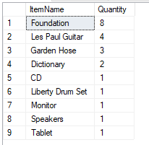

2. Find most expensive sale by date.

SELECT

saletime AS dt, MAX(dollaramount) AS max_dollar

FROM

SALESFACT

GROUP BY

saletime

ORDER BY

saletime asc;

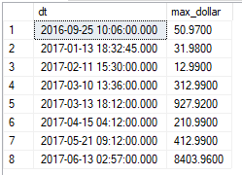

3. Find the Average cost of the sales by date

SELECT

saletime AS dt, avg(dollaramount) AS avg_dollar

FROM

SALESFACT

GROUP BY

saletime

ORDER BY

saletime asc;

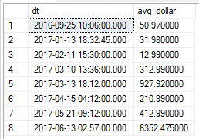

4. Find the Total dollars in sale

SELECT

SUM(DollarAmount) AS TtlSaleAmnt

FROM

SALESFACT;



5. Select total dollar amounts within each active month of each active year.

SELECT YEAR(saletime) AS SalesYear,

MONTH(saletime) AS SalesMonth,

SUM(dollaramount) AS TotalSales

FROM Salesfact

GROUP BY YEAR(saletime), MONTH(saletime)

ORDER BY YEAR(saletime), MONTH(saletime);

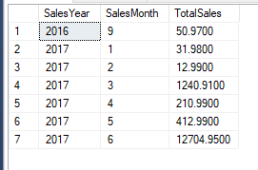

6. Select Total items sold within each active month of each active year.

SELECT YEAR(saletime) AS SalesYear,

MONTH(saletime) AS SalesMonth,

SUM(ItemsSold) AS TotalItems

FROM Salesfact

GROUP BY YEAR(saletime), MONTH(saletime)

ORDER BY YEAR(saletime), MONTH(saletime);

